 | 16.1.1 Editors - Dope Sheet - Header tools and options
Table of content
Introduction 3
Header Tabs 3
Dope Sheet Modes 3
Dope Sheet 3
Action Editor 3
Shape Key Editor 4
Grease Pencil 4
Mask 4
Cache File 4
Show Hide elements 5
Summary 5
Only Show Selected 5
Show Hidden 5
Only Show Errors 5
Filters - Dope Sheet Mode 5
Filter by Collection 5
Filter by Type 5
Options 5
Sort Data Blocks 5
Multi Word Match Search 6
Proportional Editing - All Modes 6
Keyframe Easing, Handle Type, Keyframe Interpolation, Keyframe Type - All Modes 6
Easing Mode 6
Handle Type 6
Interpolation Mode 6
Keyframe Type 7
Snapping Panel – Most modes 7
Toggle Snapping On/Off 7
Frame 7
Second 7
Nearest Market 7
Absolute Time Snap 7
Tools + Action Slots - Action Editor mode 8
Action Data Browser property 8
Action Data Browser 8
Number of Fake Users 8
Fake User 8
New Action 8
Unlink Action 8
Included data property 8
Data Browser 8
New Slot 8
Unassign Slot 9
Push Down 9
Stash 9
Only show Slot of active Object 9
Tools - Grease Pencil mode 9
Add new Layer 9
Remove Layer 9
Layer Specials 9
Duplicate layer 9
Show All 9
Hide Others 10
Lock All 10
Unlock All 10
Autolock inactive Layers 10
Merge Down 10
Copy Layer to object 10
Move Grease Pencil Layer upwards 10
Move Grease Pencil Layer downwards 10
Isolate Layer with visibility 10
Isolate Layer without visibility 10
Options 10
Real-time Updates 10
Show Seconds 11
Sync visible range 11
Show Sliders 11
Show Handles and Interpolation 11
Show Curve Extremes 11
AutoMerge Keyframes 11
Show Markers 12
Lock Markers 12
Sync Markers 12
Show Cache 12
Softbody 12
Particles 12
Cloth 12
Simulation Nodes 12
Smoke 12
Dynamic Paint 12
Rigid Body 12

Introduction

The header contains various menus and tools. This chapter here is about the tools, modes and options elements in the header.
The text menus are covered in an own chapter each. They vary too much, dependent of mode and object type.

Header Tabs

The tabs at the very left allows you to switch between the four most important editor types by one click. Dope sheet Editor, Graph Editor, Driver Editor, NLA Editor.

Dope Sheet Modes
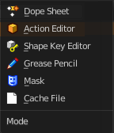
The Dope sheet has different modes. Each mode has its own purpose. In Mask mode you can for example see and edit the keyframes for mask animations, from the movie clip editor for example.

Dope Sheet
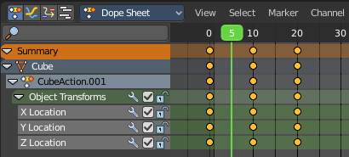
Display the keyframe animation of all currently selected object in the 3d view.

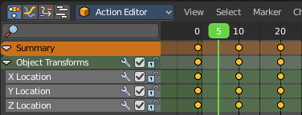
Action Editor
Display and edit the Action part of a keyframe animation of the currently active object in the 3d view. Just the data for this one object is displayed.
Actions are a generic containers for F-Curves. Actions can contain any number of F-Curves, and can be attached to any data block. For example, an action that modifies the ‘X location’ and ‘Y location’ properties can be shared across multiple objects, since both objects have ‘X location’ and ‘Y location’ properties available.
The Action editor allows you to edit the animation in various ways. For example also turn a keyframe animation into a clip for the NLA editor.
The animation data is build in a hierarchical way. From top to bottom.
Actions - Record and contain animation data.
Groups - Are groups of channels.
Channels - Contains record properties.
F-Curves - F-Curves are used to interpolate the difference between the keyframes.
Keyframes - Keyframes are used to set the values of properties bound to a point in time.

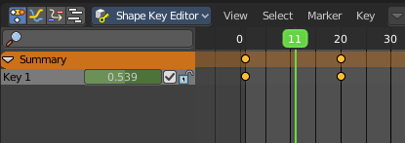
Shape Key Editor
Display and and edit the keyframes for shape key animations. Shape keys is vertex animation.

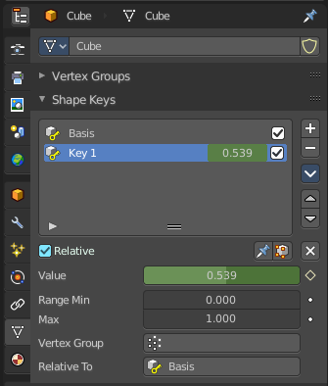

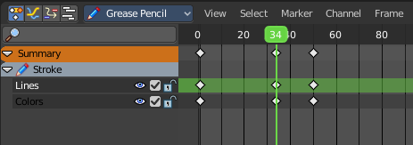
Grease Pencil
Display and and edit the keyframes for animated grease pencil strokes. This mode is for when you animate grease pencil strokes and colors at a vertex level. When you record keyframes at an object level then those keyframes gets displayed in the Dope sheet and Action mode.

Mask
Display and edit the keyframes for animated mask curves. Like from the movie clip editor.

Cache File
NOT DOCUMENTED BY BLENDER. NOT TO FIND OUT HOW TO USE.
From the Blender Manual: Cache File: Alembic Todo 2.78.

Show Hide elements
This is a group of header operators for animation channel visibility. This is present in all dopesheet modes.

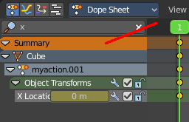
Summary
Display the Summary label above the list of elements.

Only Show Selected
Display only the data for the selected object in the list of elements. If off it displays all available animation data of the whole scene.

Show Hidden
Include channels from objects / bones that are not visible. This feature just works with Only Selected off.

Only Show Errors
Only display F-Curves and Drivers that have errors or are disabled.

Filters - Dope Sheet Mode
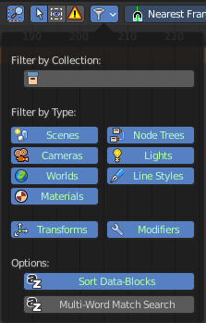
The show hide elements allows you to filter out the general elements. The Filters panel allows you to filter out further elements.
Note that this filter methods just exists for the dope sheet mode.

Filter by Collection
Just display the content from the chosen collection in the list of elements.

Filter by Type
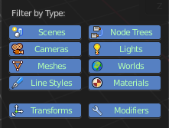
In this section you can choose what type of animation data should be displayed. The names should be self explaining.

Options

Sort Data Blocks
Alphabetically sort the data in the list of elements.

Multi Word Match Search
Enable Multi Word matching for the search in the list of elements.

Proportional Editing - All Modes

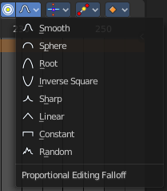
Enable proportional editing.
Proportional editing allows you for example to scale two keyframes and influence the not selected neighbour keyframes in a proportional way. Or the proportional editing of fcurve points.
The dropdown menu to choose the proportional editing falloff method is just available when the proportional tool is active.

Keyframe Easing, Handle Type, Keyframe Interpolation, Keyframe Type - All Modes

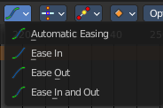
Easing Mode
Choose between different easing modes for the selected keyframes. Easing is a method to fade in and out curves.

Handle Type
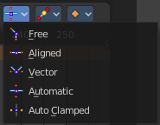
Set the handle type for the currently selected keyframes.
This is a feature for the Graph editor, where each curve point has its own handler with which you can influence the curve behaviour. But the handler type also influences how the animation curve acts at the chosen keyframes. So it has its use in the dopesheet editor too.
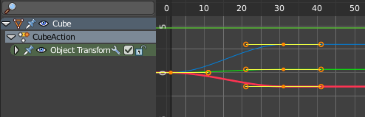

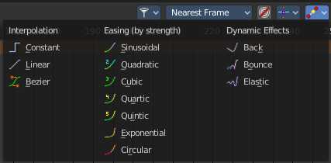
Interpolation Mode
The Interpolation mode defines how the curve acts from keyframe to keyframe. You can have a linear curve between two keyframes instead of a bent one for example.

The easing methods here in the interpolation mode menü are for the easing shape. There is also a easing menu where you can choose a easing method.

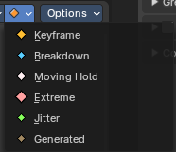
Keyframe Type
Recolor the currently selected keyframes. Or create the next keyframe with this chosen keyframe color.

Snapping Panel – Most modes
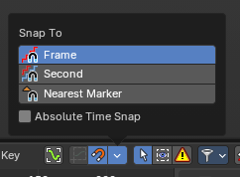
Snapping in animation editors helps align the playhead and keyframes to meaningful time-based elements, improving precision and workflow efficiency across the Timeline, Dope Sheet, Graph Editor, NLA, and Video Sequencer.
Note: This sub-subpanel is not available for Grease Pencil Dopesheet Mode

Toggle Snapping On/Off
Toggles the snapping on or off with a visual indicator.

Frame
Snaps to whole frame numbers. Ideal for frame-accurate editing instead of sub-frame timeline cursor placement.

Second
Snaps to time intervals measured in seconds. Useful for audio syncing or time-based pacing.

Nearest Market
Snaps to the closest timeline marker. Great for aligning actions to scene events or beats.

Absolute Time Snap
When enabled, snapping uses absolute time rather than relative pixel proximity. Ensures consistent snapping behavior regardless of zoom level or cursor position.

Tools + Action Slots - Action Editor mode

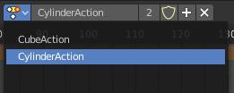
Action Data Browser property
When there is more than one animated object in the scene then you have most probably more than one action in the scene too. The Action Data Browser allows you to display, select and rename the available actions in the scene.

Action Data Browser
The list of available actions in the scene.

Number of Fake Users
Displays the current number of fake users for the active action.

Fake User
Assign a fake user to this action. Fake users is a odd concept to keep data in the scene even if it has no user somewhere. The fake user is then a dummy user so that the object is not deleted when saving the scene.

New Action
Add a new blank action.

Unlink Action
Delete the current active action.

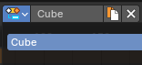
Included data property
This slot identifies which data is included in the action clip. This is useful to animate multiple elements together. You can assign the objects in the Animation Panel or Dopesheet in Action Clip mode. Its identifier natge is used to find the right slot wehn assigning an Action.

Data Browser
The list of available objects in the action.

New Slot
Add a new object to the animation slot.

Unassign Slot
Delete the current active object from the animation slot

Push Down
Adds the active action on to the NLA stack as a contributing strip. The same can be done by pressing the Push Down button in the NLA Editor.

Stash
Stashes the active action on to the NLA stack. This means it is added as a non-contributing stack in the same way that it would if you were creating a new action instead.
Note
Push down and Stash adds the action to the NLA stack. It is cleared / unassigned from the active action slot.

This means that the action cannot be edited anymore fom the Action or Graph Editors, unless you enter “Tweak Mode” on the corresponding strips later.

Only show Slot of active Object
Show or hide other action slots.

Tools - Grease Pencil mode
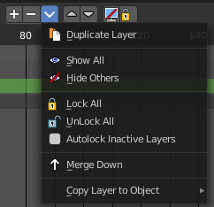

Add new Layer
Adds a new blank grease pencil layer.

Remove Layer
Removes the currently selected grease pencil layer.

Layer Specials
A menu with grease pencil functionality.

Duplicate layer
Duplicates the currently selected grease pencil layer.

Show All
Shows all hidden grease pencil layers.

Hide Others
Hides all grease pencil layers but the selected.

Lock All
Locks all grease pencil layers.

Unlock All
Unlocks all grease pencil layers.

Autolock inactive Layers
Lock automatically all layers except active one.

Merge Down
Merge the current layer with the layer below.

Copy Layer to object
Copies the grease pencil layer to another object.

Move Grease Pencil Layer upwards
Moves the grease pencil layer upwards in the hierarchy.

Move Grease Pencil Layer downwards
Moves the grease pencil layer downwards in the hierarchy.

Isolate Layer with visibility
Locks and hides the currently active grease pencil layer.

Isolate Layer without visibility
Locks the currently active grease pencil layer.

Options
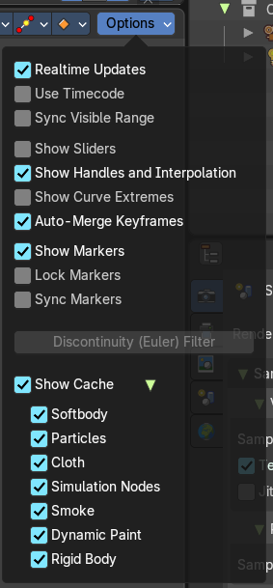

Real-time Updates
When transforming keyframes then this transformation is also immediately visible in other editors.

Show Seconds
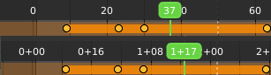
Show the timing in the timeline area in seconds instead of frames.

Sync visible range
Synchronize the visible timeline range with other visible time based editors. When you zoom in or out in the one editor, then it zooms in or out in the other editor too. Each editor to sync needs to have Sync Visible Range ticked.

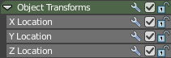
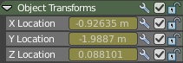
Show Sliders
Shows the value sliders for f-curve channels in the channel list.

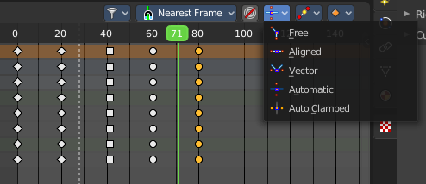
Show Handles and Interpolation
With this option on the keyframes shows different shapes that depends of their handle type.
With this option off all keyframes shows as diamond shape.

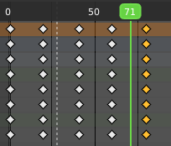

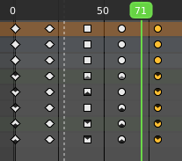
Show Curve Extremes
Shows the curve extremes at the keyframe icons.

AutoMerge Keyframes
Automatically merge nearby keyframes.

Show Markers
Display the markers row at the bottom of the view.

Lock Markers
Make the markers uneditable.

Sync Markers
Sync markers with keyframe edits. When you move the keyframes, then the markers will move too.

Show Cache
Show the status of cached frames in the timeline.

Softbody
Show the status for softbody objects.

Particles
Show the status for Particles objects.

Cloth
Show the status for Cloth objects.

Simulation Nodes
Show the status for Simulation Nodes objects.

Smoke
Show the status for Smoke objects.

Dynamic Paint
Show the status for Dynamic Paint objects.

Rigid Body
Show the status for Rigid Body objects.

